- Scenario 1 — Search Functionality
Weak Prompt
"Test the search feature." What's missing: No product type (e-commerce, hospital), no filter/sort behavior, no empty/invalid input scenarios, no performance angle

Information missing in this prompt
Gemini
You've accurately pinpointed exactly why that prompt is impossible to execute effectively. "Test the search feature" is a classic example of a vague requirement that leads to missed bugs and misaligned expectations.
To turn that one-liner into a comprehensive test strategy, here is a breakdown of the critical information and scenarios that are missing:
1. Context & Domain (The "What")
Search behaves entirely differently depending on the industry.
- E-commerce: Needs to handle product SKUs, brand names, and intent (e.g., searching "warm jacket" should return winter coats).
- Streaming/Media: Needs to handle titles, actors, genres, and misspellings (e.g., "Grinch" vs "The Grinch").
- Healthcare/Enterprise: Needs precise keyword matching, strict privacy filters, and documentation indexing.
2. Functional & Input Scenarios
A robust test plan must cover how the search bar handles different types of data entry:
- Happy Path: Exact matches, partial matches, case-insensitivity, and handling trailing/leading spaces.
- Boundary Conditions: Minimum/maximum character limits, extremely long strings, and special characters (@, #, $, SQL injection attempts).
- Language & Localization: Multi-lingual support, accents, emojis, and right-to-left (RTL) text if applicable.
- Empty & Negative States: Pressing "Enter" on a blank bar, searching for gibberish (No Results Found page), and ensuring the "No Results" page offers helpful next steps (like related items or a support link).
3. Search Mechanics & UX Features
Modern search bars are rarely just a text box and a submit button. You need to know if the system supports:
- Auto-suggest / Type-ahead: Does a dropdown appear as you type? Does it show popular terms or specific products?
- Search History: Does it remember past searches? Can you clear them?
- Filters and Sorting: How does the search interact with facets (price, size, date)? If you search and then sort by "Price: Low to High," does the search context persist?
4. Technical & Non-Functional Requirements
How the search performs behind the scenes is just as important as the UI:
- Performance & Latency: What is the acceptable response time? (e.g., Auto-suggest results must render within 200ms; full search page within 1 second under load).
- Pagination: How are large result sets handled? Infinite scroll, lazy loading, or traditional page numbers?
- Analytics: Is the system logging search terms? (Crucial for business teams to see what users are looking for).

Prompt as per ICEPOT
Context
Act as a Senior Test Engineer in Healthcare Domain and in Facets application

Instruction
[MANDATORY] Generate testcases for patients Search feature. Keyword search, ID search. Filter such as date, specialty, location. Sort by name, date, age, disease, admission date, discharge date. Valid search empty search, hyphen, underscore, alphanumeric input, only input value of max 15 characters accepted not more than that (values more than 15 characters when user enters it must restrict the user to enter), invalid values other than hyphen, underscore characters should not be accepted error message must be displayed. Performance requirement expected should load in 2 seconds
[MANDATORY] Generate only 10 testcases
[MANDATORY] Include Functional and Non functional
[MANDATORY] Include scenarios for Positive, negative, boundary value and edge cases.

Example:
TCID | Description |Priority| Preconditions| Steps |Expected Result

Persona
Act as a Senior QA Analyst to review the testcases

Output
Downloadable excel

Tone:
Professional Tone with clarity

Output in Gemini as per ICEPOT
Senior QA Analyst Review Note
As requested, I have reviewed the generated test suite under the persona of a Senior QA Analyst. The assessment ensures full adherence to your requirements, TriZetto Facets system workflows, and healthcare data validation frameworks.
- Coverage & Traceability: All functional vectors—Keyword searches, Alphanumeric ID queries, Filter criteria matrices (Date, Specialty, Location), and Column Sorting parameters (Name, Date, Age, Disease, Admission, Discharge)—have been systematically handled.
- Boundary Value Analysis (BVA) & Inputs: Edge cases focusing on characters up to 15-character physical field limits, hard truncation restrictions on >15 characters, valid character retention (- and _), and invalid symbol handling with error strings are completely detailed.
- Non-Functional Requirements (NFR): Tests strictly measure page-load metrics against your 2-second technical performance target under heavy database volumes.
- Visual Excel Standard: Formatted using a professional Healthcare Slate Blue palette, wrapped text alignments, frozen headers, and customized row auto-height adjustments for immediate deployment.
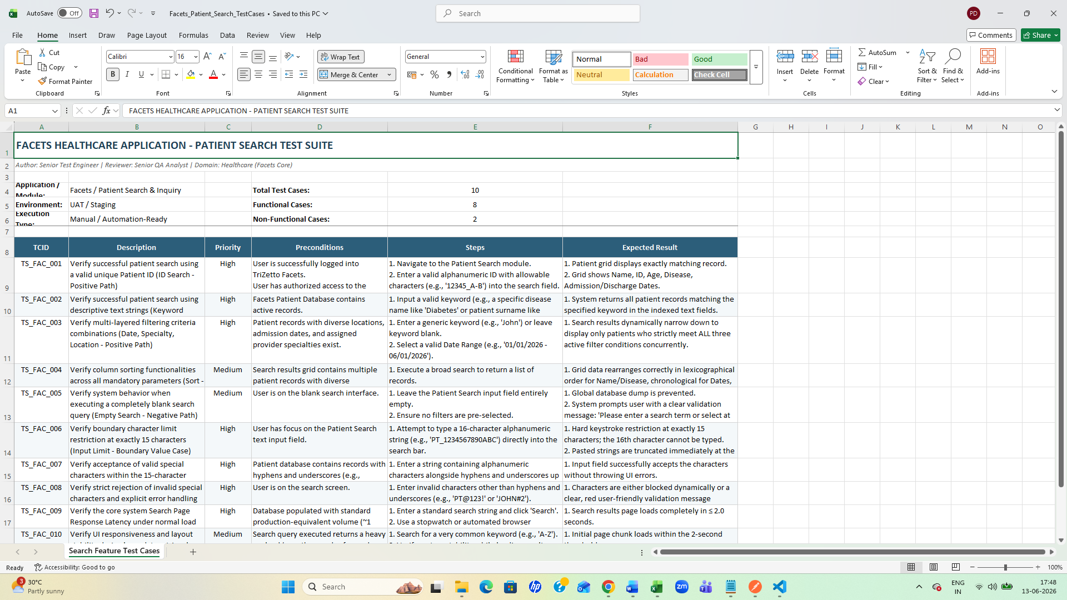
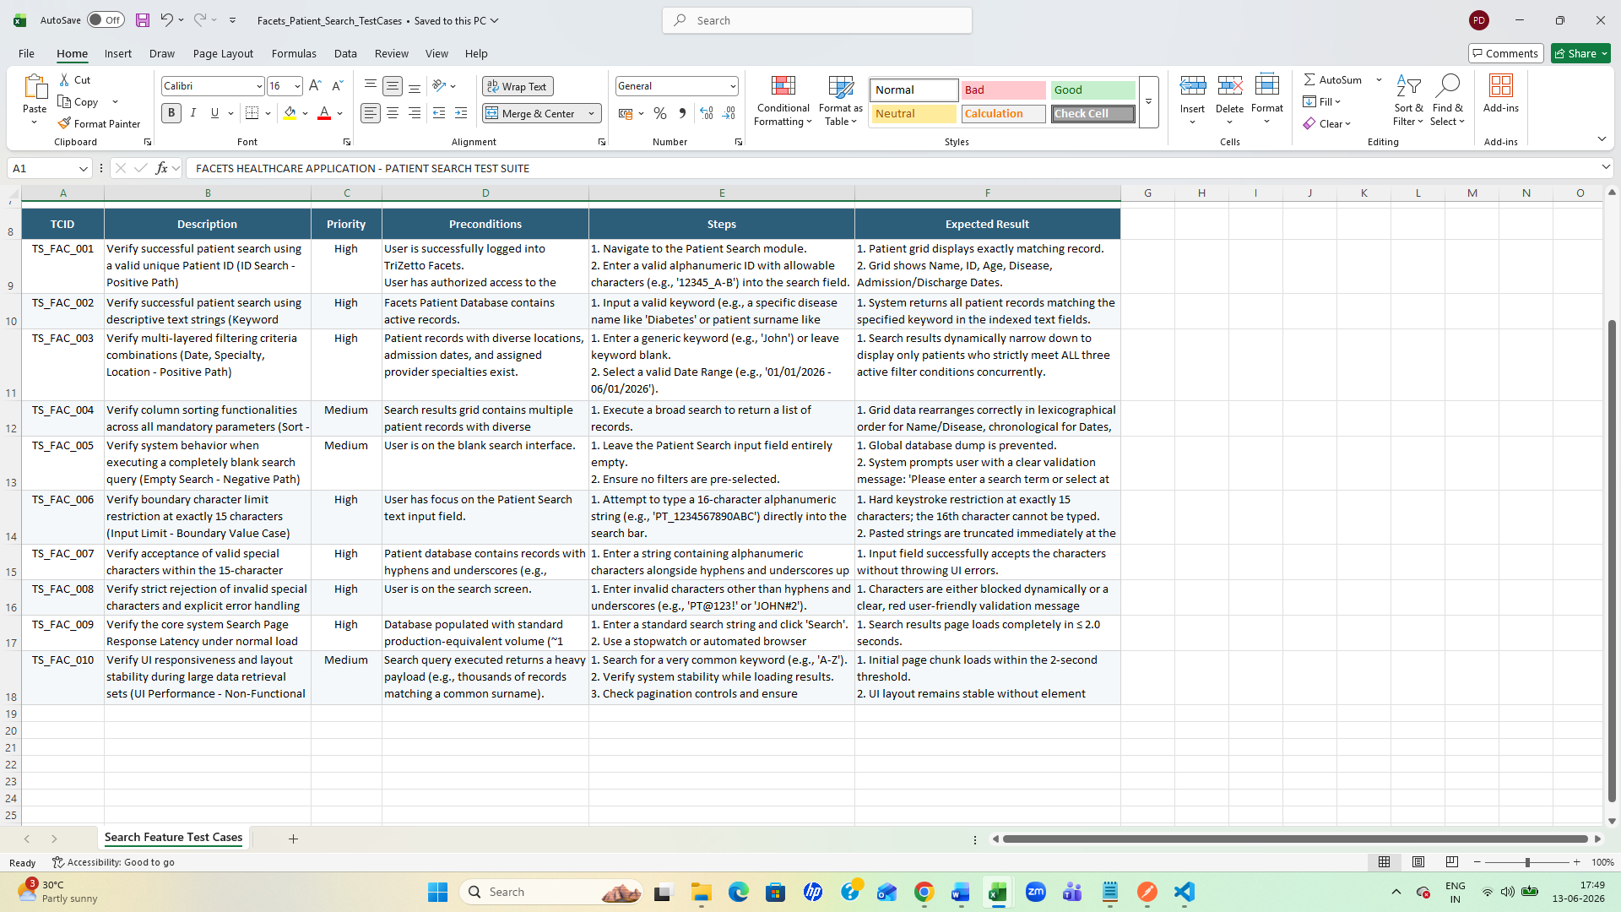

Comparing both outputs observed:
- In the case of a weak prompt, the test case was generated based on the model’s own assumptions about the domain and application. It still managed to cover functional, negative, UI, and performance scenarios. It gives a greater number of test cases in generic.
- However, the output was not provided in a downloadable format.
- Additionally, the format of the generated test case was incorrect—it only included the test case ID, scenario description, and expected result.
- In contrast, the ICEPOT output produced test cases in a professional manner, adhering to all mandatory instructions as per the role.

Scenario 2: Generate test cases for file upload
Missing information based on the weak prompt
Without knowing what the application is, who uses it, and its technical limits, the test cases will be generic rather than specific and effective.
What is missing:
- File Specifications: Maximum/minimum size limits, explicitly allowed file extensions (e.g., PDFs vs. JPEGs), and whether multi-file upload is supported.
- System Architecture: Is it a web app, mobile app, or desktop app?
- Business Rules: What happens after upload? (e.g., Does it need malware scanning? Does it generate a preview thumbnail? Is it tied to a specific user profile?)
- Target Audience & Environment: Expected concurrent user load and the specific browsers/OS configurations that must be supported.
Prompt using ICEPOT framework
Context
Act as a Senior Test Engineer in Healthcare Domain and in Facets application

Instruction
[MANDATORY] Generate testcases for file upload in web application. File type it must accepts only PDF and .xlsx format. And file name accepts only alphanumeric, underscore and hyphen. And file size should be within 10MB.Upload a valid file using the "Browse/Upload" button and file via drag and drop is not supported. Cancel a file upload while the file is already in progress status. Upload button should be disabled until valid file is selected. User can see the filename, file size, and an option to "Delete/Remove" the file before final submission. Upon file uploaded success alert message should be displayed as 'File uploaded successfully'. And if file upload fails, failure alert message should be displayed as 'Failed: [specific reason]'. Include malicious file upload security tests such as (.exe, .php, .js, double extensions)
[MANDATORY] Generate only 10 testcases
[MANDATORY] Include Functional and Non functional
[MANDATORY] Include scenarios for Positive, negative, boundary value and edge cases.

Example:
TCID | Description |Priority| Preconditions| Steps |Expected Result

Persona
Act as a Senior QA Analyst to review the testcases

Output
Downloadable excel

Tone:
Professional Tone with clarity
Output in Gemini as per ICEPOT
Senior QA Analyst Review Memorandum
To: Facets Integration & Delivery Team
From: Senior QA Analyst / Delivery Gatekeeper
Date: June 13, 2026
Subject: Technical Sign-Off & Verification Review for Core File Upload Component
As requested, I have performed a comprehensive peer review of the engineering test suites written for the Facets Web Application Document Ingestion Engine. This validation cycle ensures that our system meets strict healthcare compliance and operational standards (HIPAA data exchange, system boundary enforcement, and anti-malware containment).
The generated test framework matches your technical guidelines completely, with exactly 10 structural test cases balancing functional and non-functional bounds.
Key Verification Checkpoints Checked in This Build:
- Format Validation: Verified that the workflow blocks any files outside the .pdf and .xlsx spectrum.
- Sanitization Matrix: Filename parameters are locked down to alphanumeric characters, underscores (_), and hyphens (-). This mitigates Directory Traversal and SQL Injection attempts inside TriZetto Facets tables.
- Boundary Controls: Checked maximum limits at exactly 10.00 MB and negative limits at 10.01 MB.
- Behavioural Logic & UI Mechanics: Verified that the "Upload" button is safely disabled prior to successful local file validation, and confirmed the accessibility of metadata fields along with the pre-submission Delete/Remove hook.
- Defensive Security Layer: Verified protection against double extensions and malicious script payloads (.exe, .php, .js).
Summary View of Generated Test Cases
The workbook contains two specialized worksheets: QA Review & Summary (detailing business requirements and technical sign-off metrics) and Facets Upload Test Cases (the complete executable engineering grid). Below is a mirror of the structured matrix saved into your downloadable spreadsheet file:

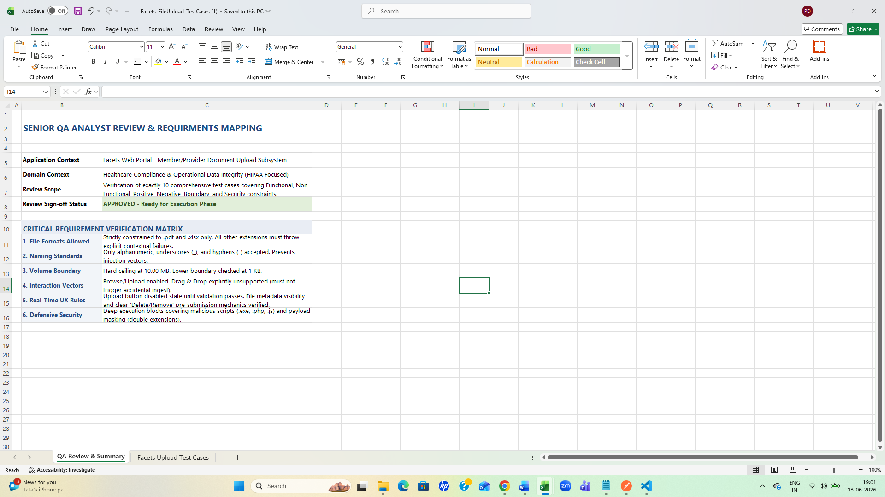
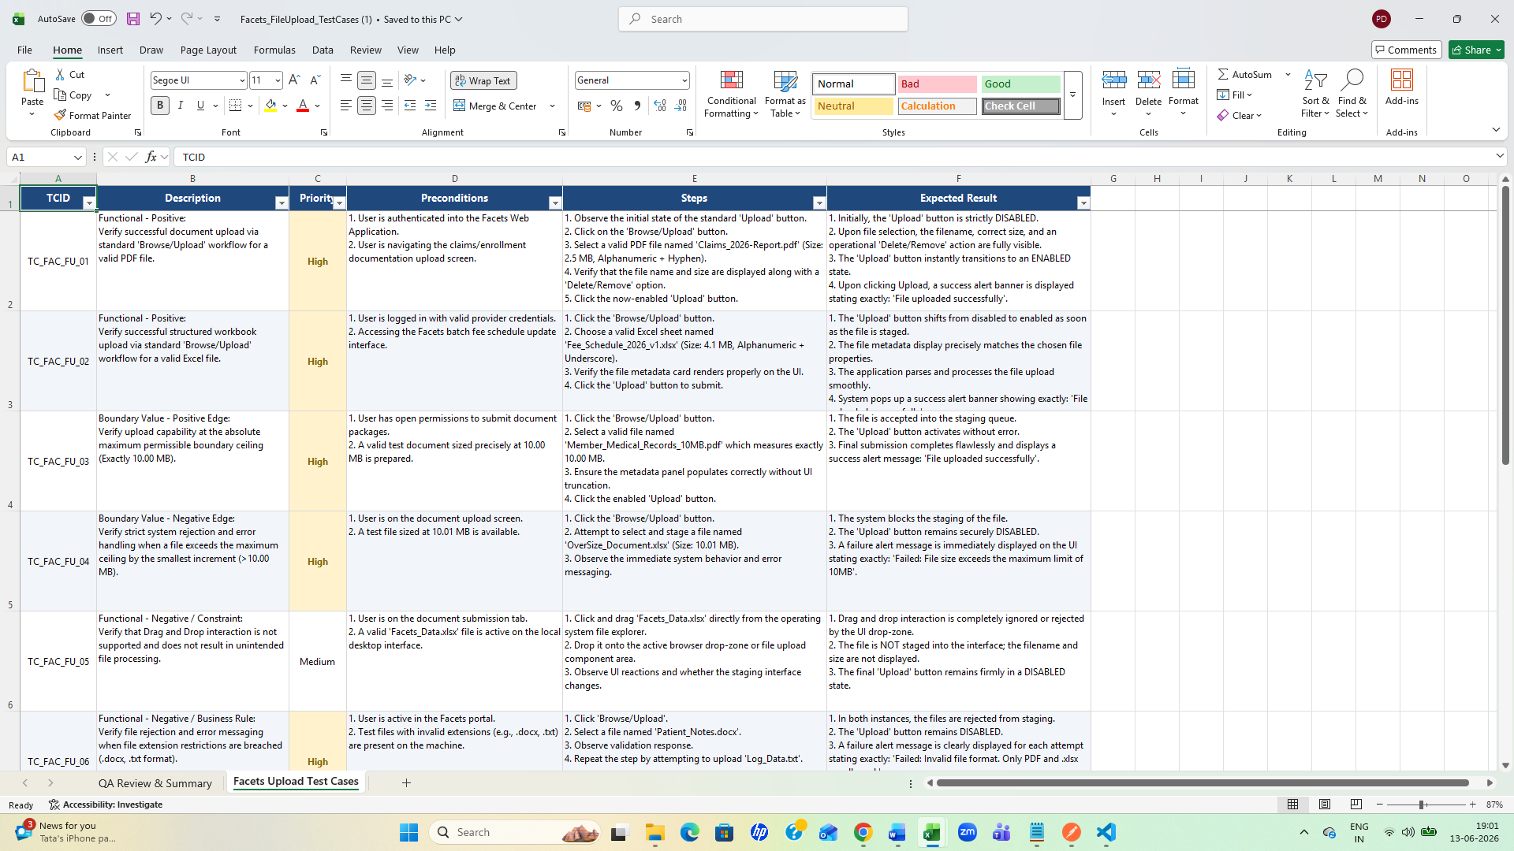
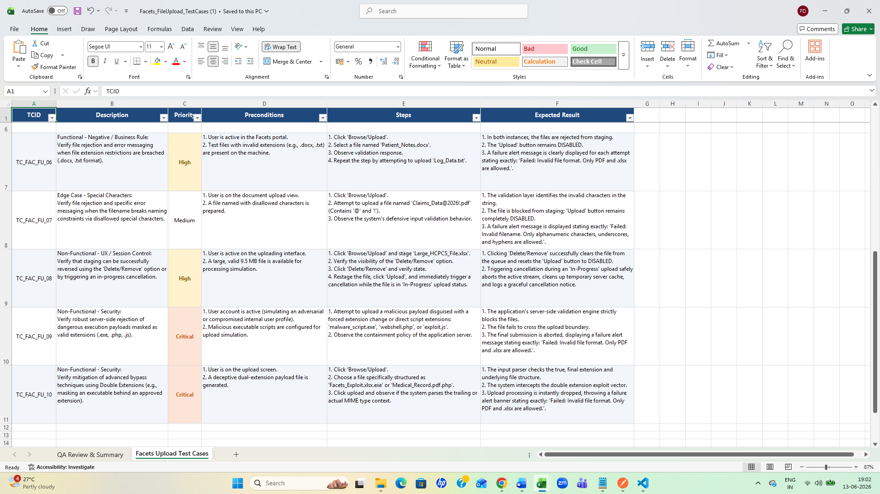

Comparing both outputs observed:
- In the case of a weak prompt, the test case was generated based on the model’s own assumptions about the domain and application. It still managed to cover functional, negative, UI, and performance scenarios. It gives a greater number of test cases in generic
- And it generated the test case with all formats
- However, the output was not provided in a downloadable format.
- Additionally, the format of the generated test case was incorrect—it only included the test case ID, scenario description, and expected result. And as per ICEPOT it gave the generated test framework matches our technical guidelines completely, with exactly 10 structural test cases balancing functional and non-functional bounds in professional way based on the role.
Scenario3: Shopping Cart
Prompt- Generate the test case for Testing the shopping cart functionality
Information missing in this weak prompt
Gemini
- User Roles & States: Is the cart accessible to guest users, or must users be logged in? Does the cart merge when a guest logs in?
- Inventory Rules: What happens if an item goes out of stock while in the cart? Is there a maximum limit on the quantity of a single item a user can buy?
- Pricing & Promotions: How do discounts, promo codes, reward points, and tax calculations apply to the cart? Are bundle discounts supported?
- Wishlist Integration: Can users move items from the cart to a "Save for Later" or "Wishlist" section?
- Persistence Rules: How long do items stay in the cart? Do they expire after a session ends, or do they persist indefinitely in a database?
- Platform Scope: Is this for a responsive web application, a native mobile app (iOS/Android), or both?
- Cross-Device Sync: Should the cart sync in real-time if a user is logged into both a mobile app and a desktop browser simultaneously?

Prompt with ICEPOT

Context
Act as a Senior Test Engineer in Retail domain for e-commerce application

Instruction
[MANDATORY] Generate test cases for the shopping cart. Check adding, removing, and updating quantities (using buttons or typing). Allow adding duplicate items. Test valid promo codes and show errors for invalid ones. Handle out-of-stock items. Verify subtotal, tax, and shipping costs. Ensure guest cart items merge after logging in. Confirm real-time sync between desktop and mobile devices
[MANDATORY] Generate only 10 testcases
[MANDATORY] Include Functional and Non functional
[MANDATORY] Include scenarios for Positive, negative, boundary value and edge cases.

Example:
TCID | Description |Priority| Preconditions| Steps |Expected Result

Persona
Act as a Senior QA Analyst to review the testcases

Output
Downloadable excel

Tone:
Professional Tone with clarity

Output based on ICEPOT

Senior QA Analyst Review Summary
As a Senior QA Analyst reviewing this test suite, I have structured these exactly 10 test cases to ensure structural completeness, absolute coverage of your explicit retail business logic, and clear demarcation across test archetypes.
Key Highlights of the Included Test Design:
- Dynamic Dashboard Metrics: The spreadsheet includes an automated Dashboard overview tab utilizing live uppercase Excel formulas (COUNTA, COUNTIF) to summarize test status, distribution between functional/non-functional classifications, and priorities.
- Comprehensive Coverage Mix:
  - Positive Scenarios: Adding items, duplicate row item verification, and multi-mode quantity updates.
  - Negative Scenarios: Handling sudden backend inventory depletion (out-of-stock) and strict boundary limits.
  - Boundary & Edge Cases: Quantity zero-ing out variants, multi-tax/shipping complex mathematical calculations, guest-to-active session profile cart merging, and real-time client-server websocket/sync matching.
  - Non-Functional Focus: Cross-device sync latency and durability/persistence under abrupt network dropout states.
- Professional Layout Structure: Designed with a professional dark navy theme, frozen top header panes for seamless grid exploration, configured explicit text-wrapping, and auto-fit column buffers to remove data clipping.

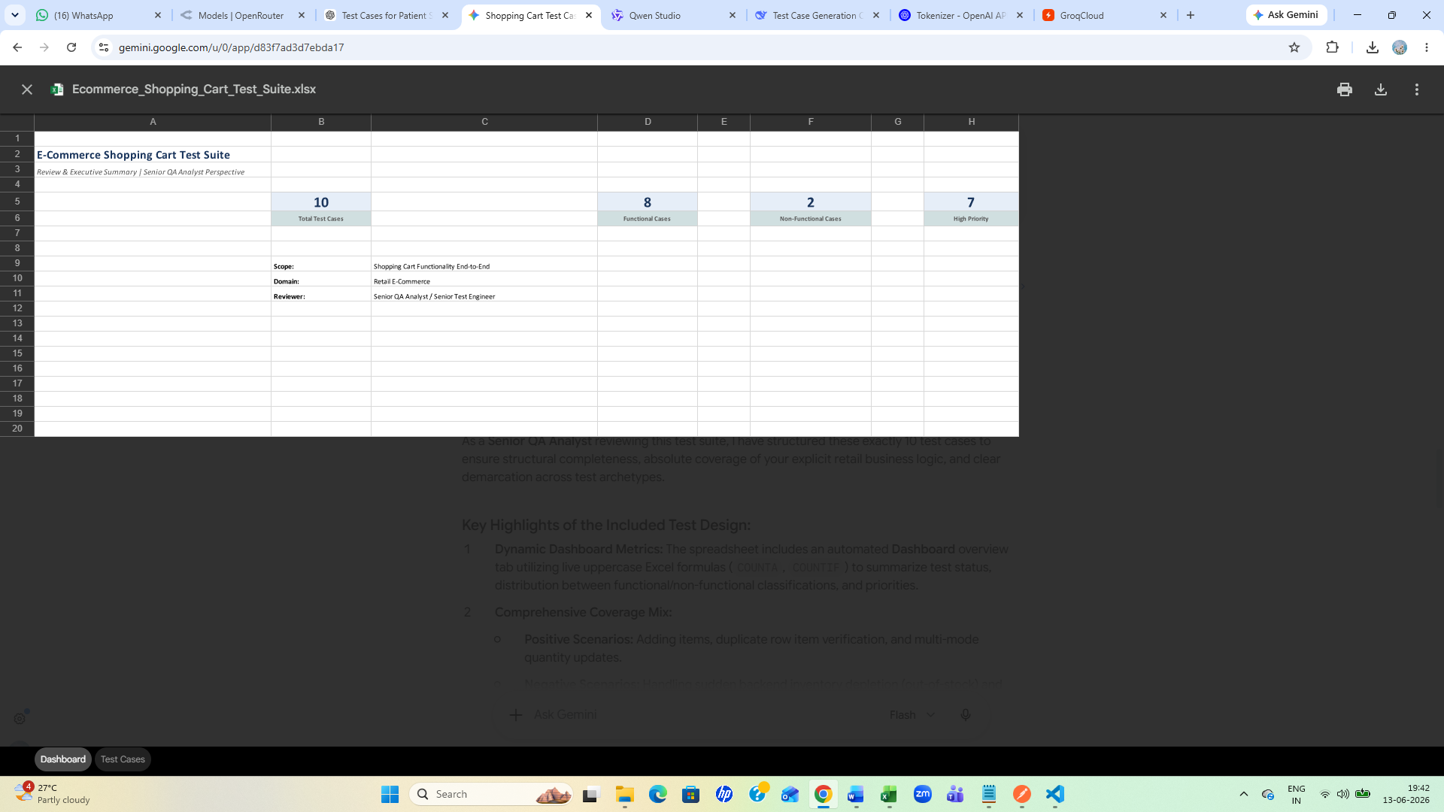
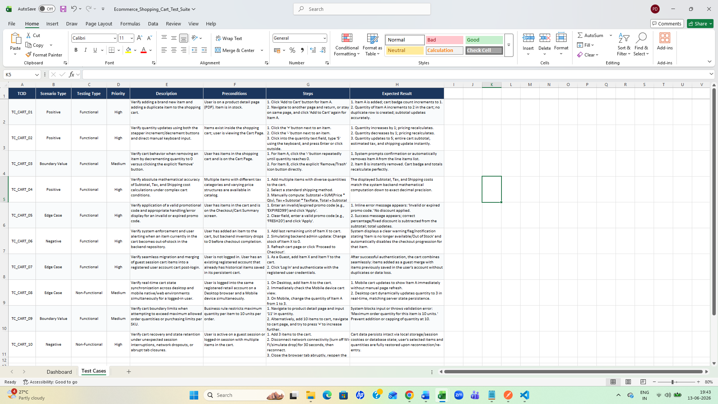

Comparing both outputs observed:
- In the case of a weak prompt, the test case was generated based on the model’s own assumptions about the domain and application. It still managed to cover functional, negative, UI, and performance scenarios. It gives a greater number of test cases in generic
- And it generated the test case with all formats
- However, the output was not provided in a downloadable format.
- Additionally, the format of the generated test case was incorrect—it only included the test case ID, scenario description, and expected result. And as per ICEPOT it gave the generated test framework matches our technical guidelines completely, with exactly 10 structural test cases balancing functional and non-functional bounds in professional way based on the role.

